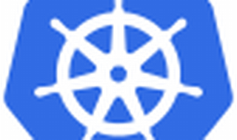

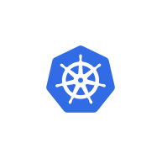

Explore

Certainly! **AKS** stands for **Azure Kubernetes Service**. It is a managed Kubernetes service provided by Microsoft Azure that allows you to quickly deploy and manage cloud-native applications using Kubernetes. [With AKS, you can create and manage Kubernetes clusters without the hassle of manual setup and maintenance1](https://azure.microsoft.com/en-us/products/kubernetes-service/). Here are **five free reference links** where you can learn more about AKS and Kubernetes:

1. [**Microsoft Azure Kubernetes Service (AKS) Documentation**](https://learn.microsoft.com/en-us/azure/aks/): This official documentation provides quickstarts, tutorials, and samples to help you get started with AKS[2](https://learn.microsoft.com/en-us/azure/aks/).
2. [**Kubernetes Learning and Training**](https://azure.microsoft.com/en-us/resources/training-and-certifications/kubernetes/): Explore videos, articles, books, and technical webinars related to Kubernetes, including AKS[3](https://azure.microsoft.com/en-us/resources/training-and-certifications/kubernetes/).
3. [**Introduction to Kubernetes on Azure**](https://learn.microsoft.com/en-us/training/paths/intro-to-kubernetes-on-azure/): This learning path covers the basics of Kubernetes, AKS cluster architecture, operations, scalability, and more[4](https://learn.microsoft.com/en-us/training/paths/intro-to-kubernetes-on-azure/).
4. [**AKS Tech**](https://akstech.com.sg/): AKS Tech is an award-winning digital agency based in Singapore. [While not directly related to Azure AKS, their website emphasizes web development, eCommerce, mobile apps, and digital marketing](https://azure.microsoft.com/en-us/products/kubernetes-service/)[5](https://akstech.com.sg/).
5. [**Phippy Goes to the Zoo**](https://azure.microsoft.com/en-us/resources/training-and-certifications/kubernetes/): An educational adventure presented in the style of an illustrated children’s book, where Phippy the giraffe and Zee the zebra explore Kubernetes concepts like pods and deployments[3](https://azure.microsoft.com/en-us/resources/training-and-certifications/kubernetes/).

Feel free to explore these resources to enhance your understanding of AKS and Kubernetes! 🚀🌟